**Video 10**

**CPU VS GPU Video Link is there in screenshot check it.  
Video on Attention Concept.**

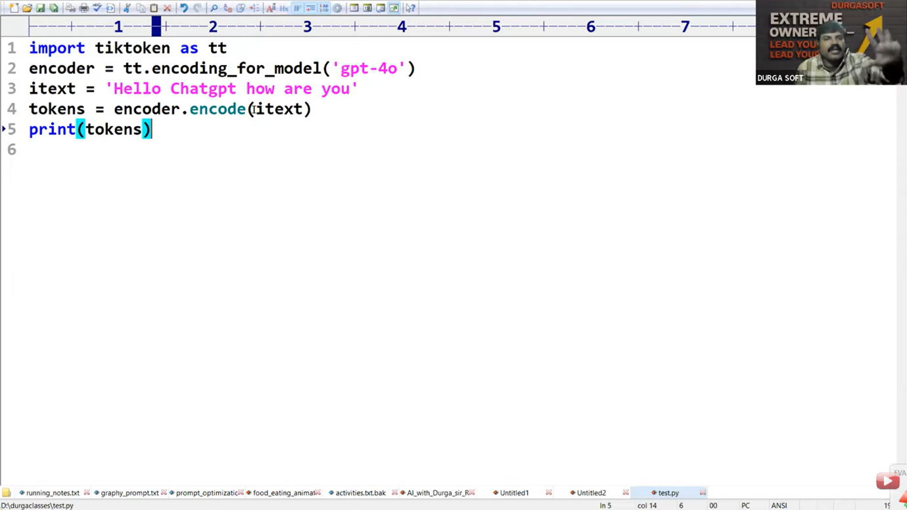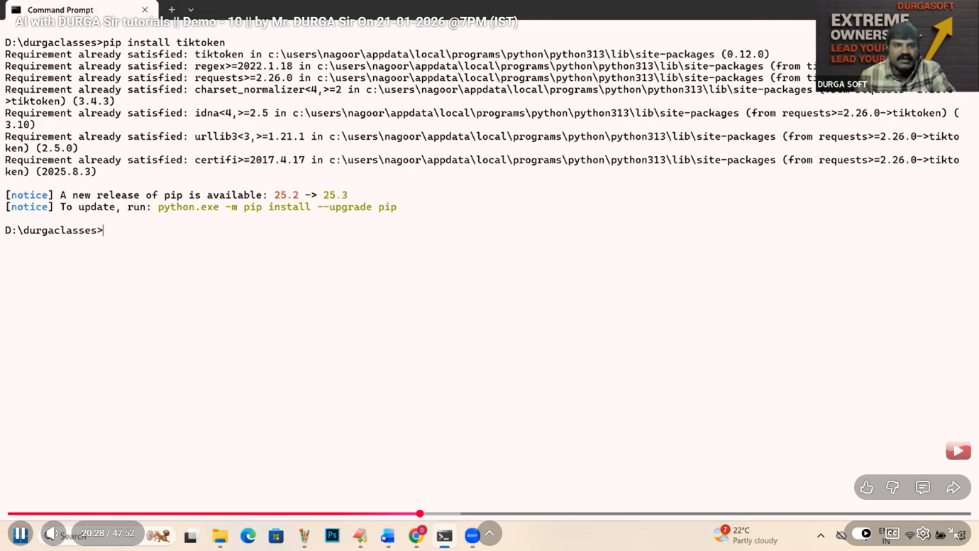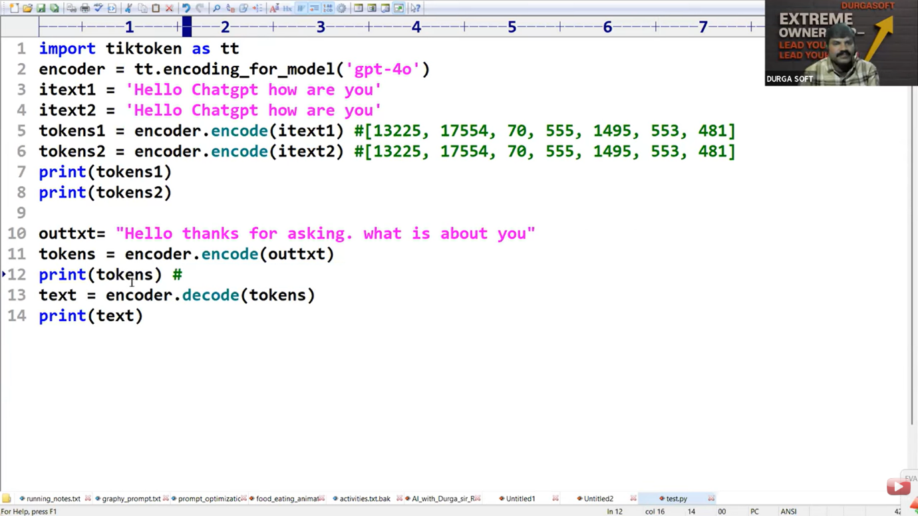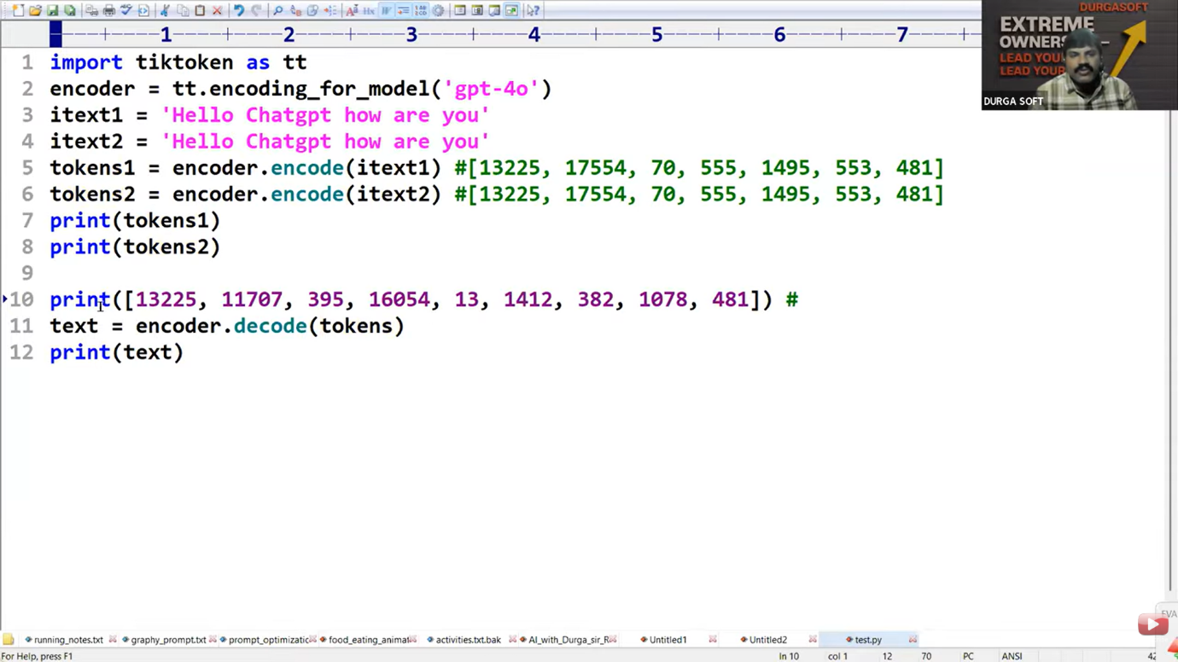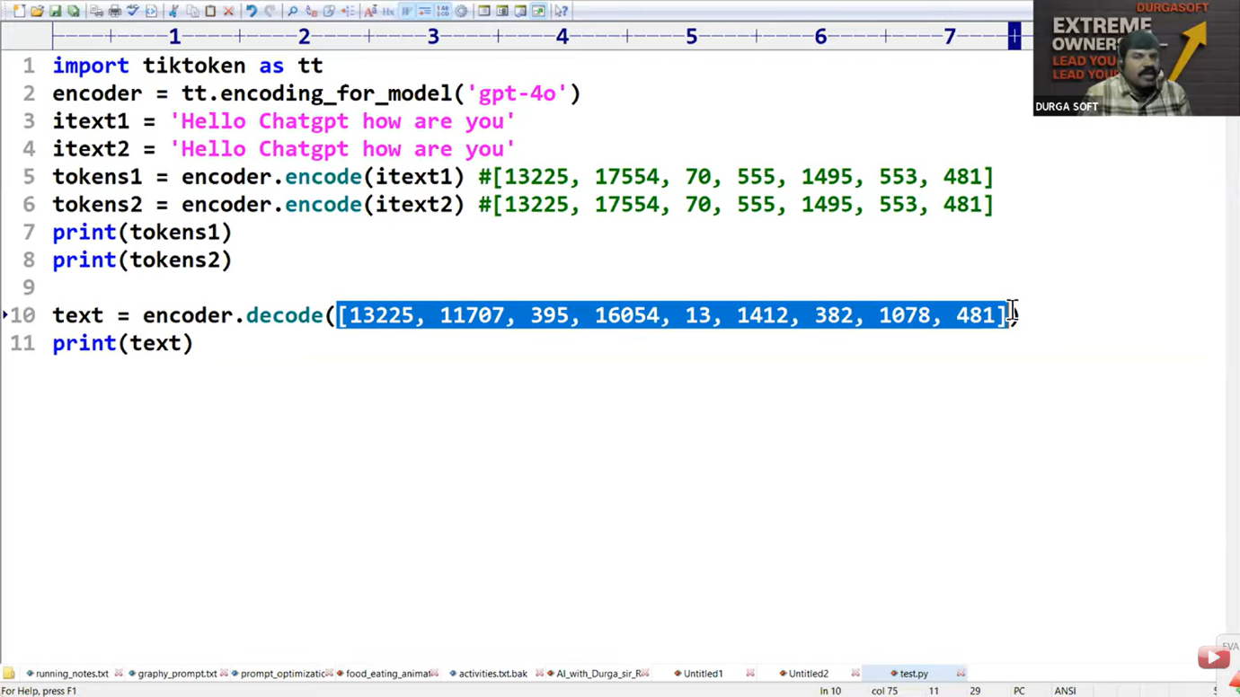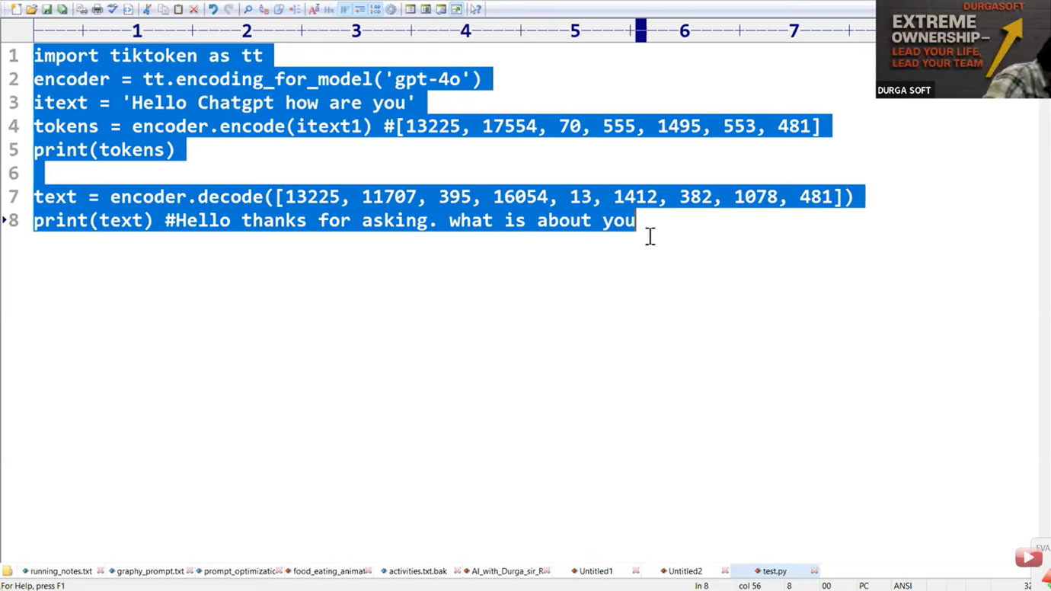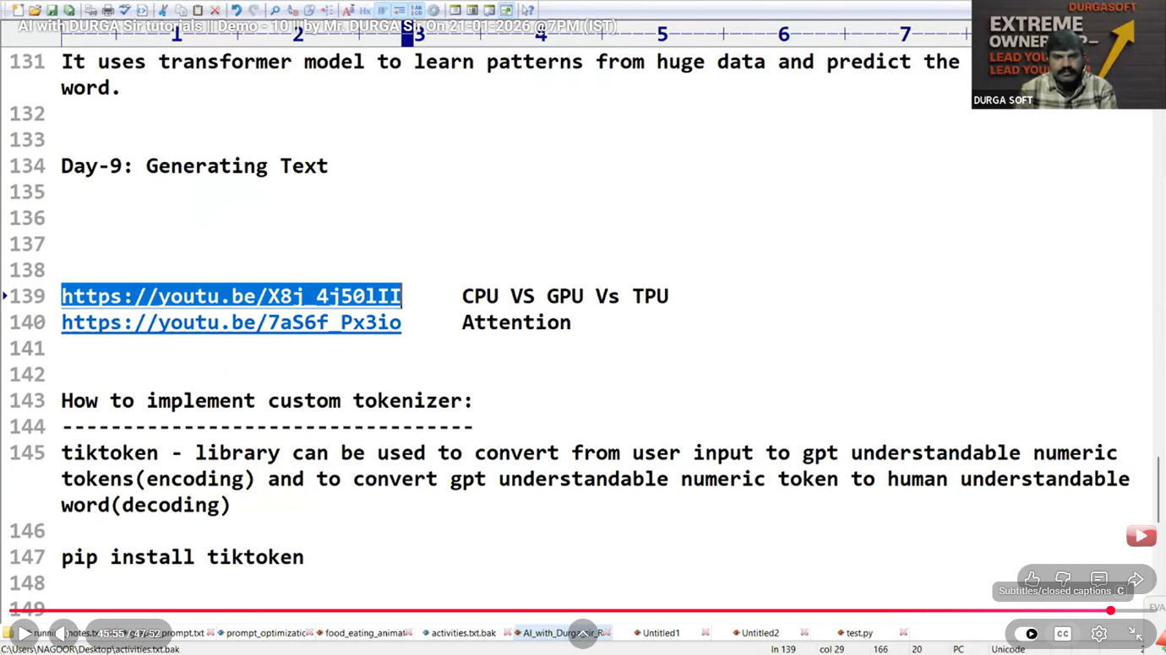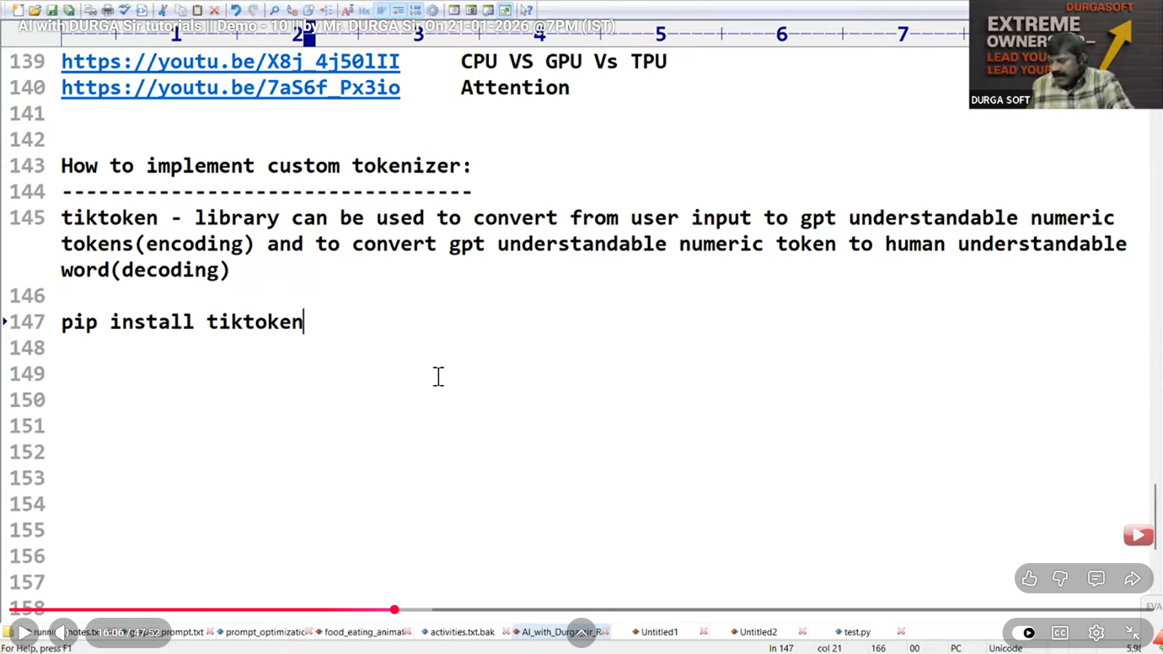

**Video 11**

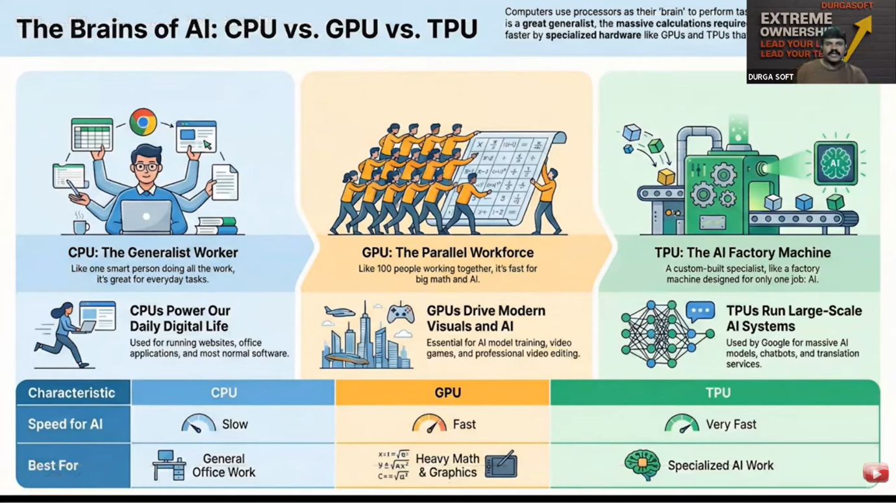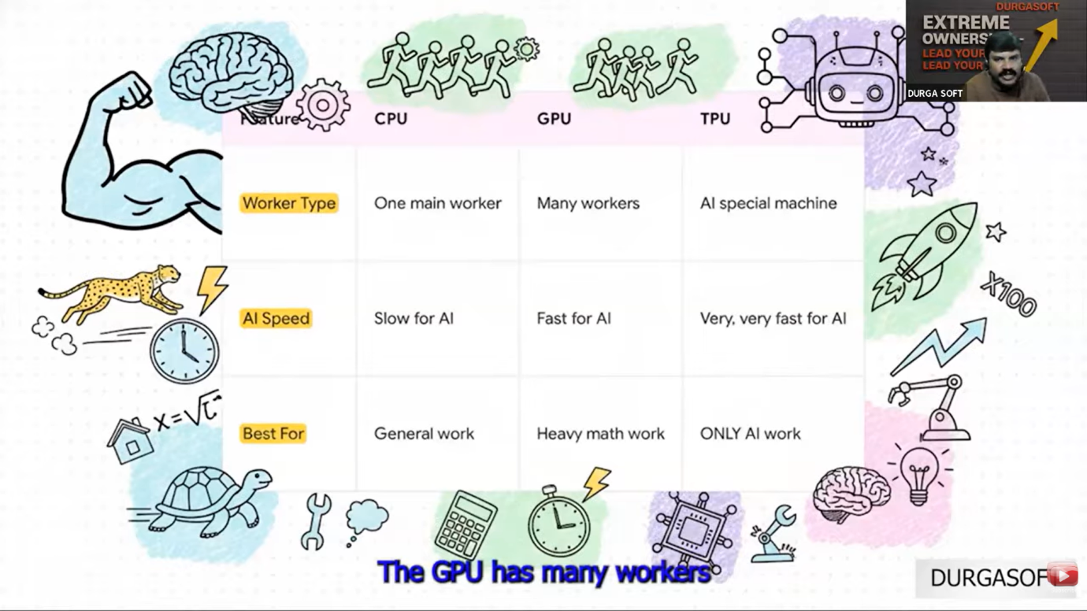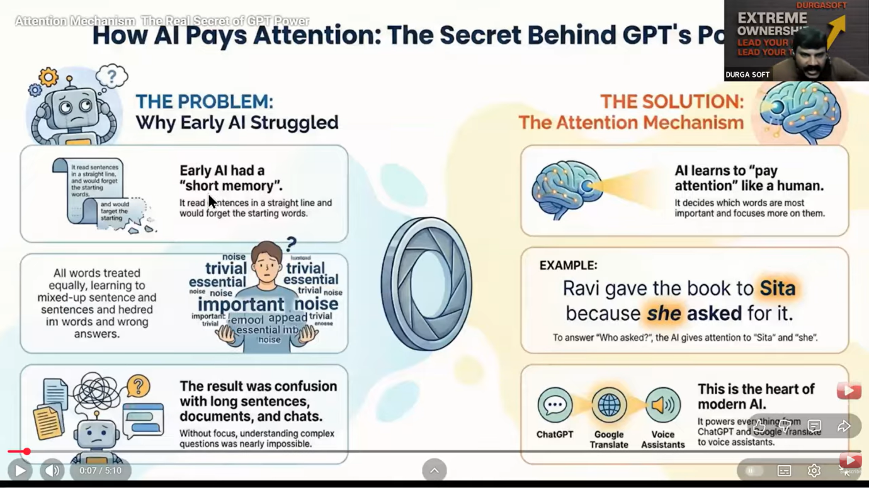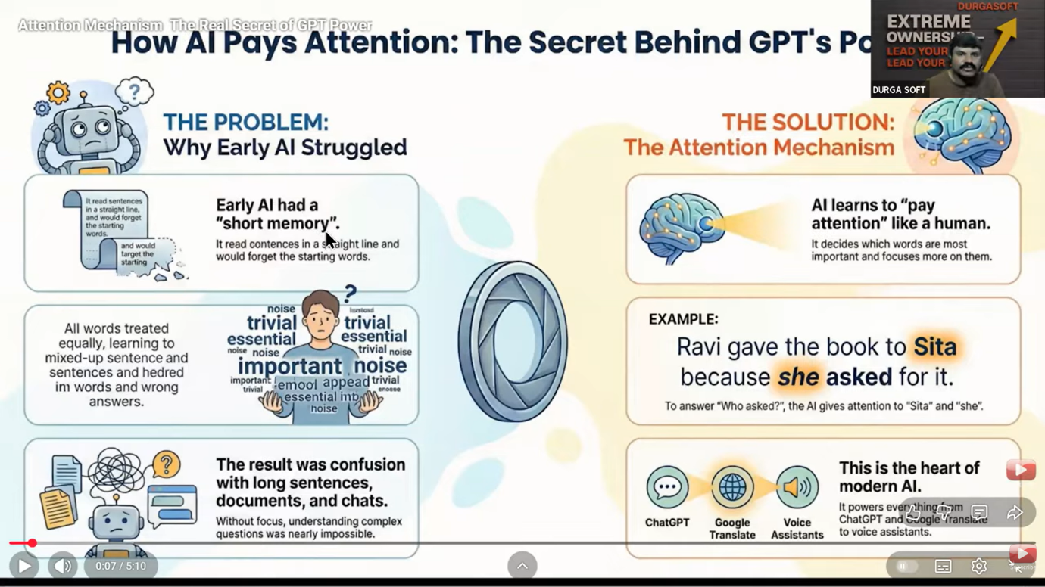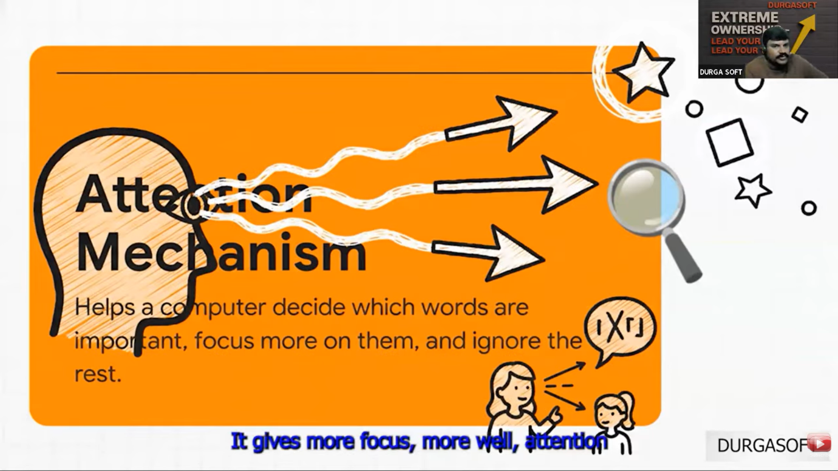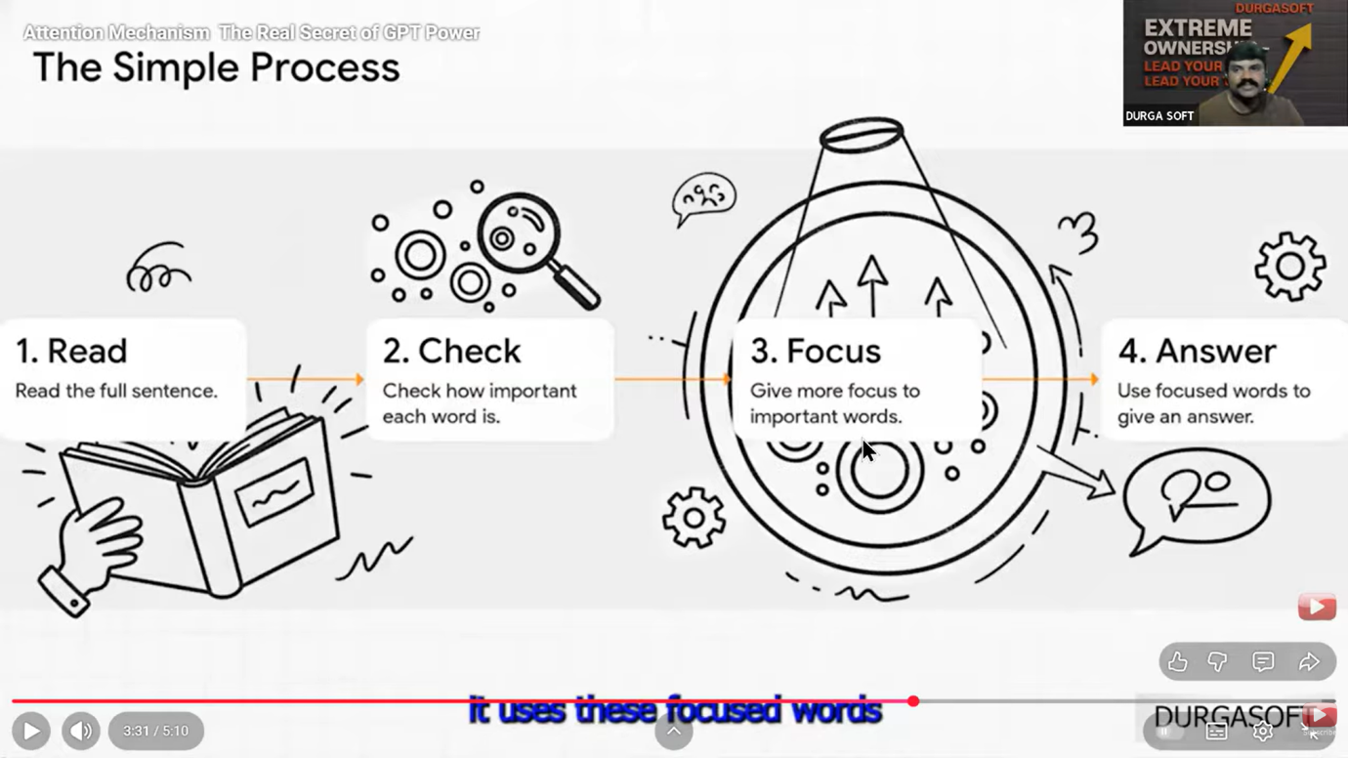

**Video 12**

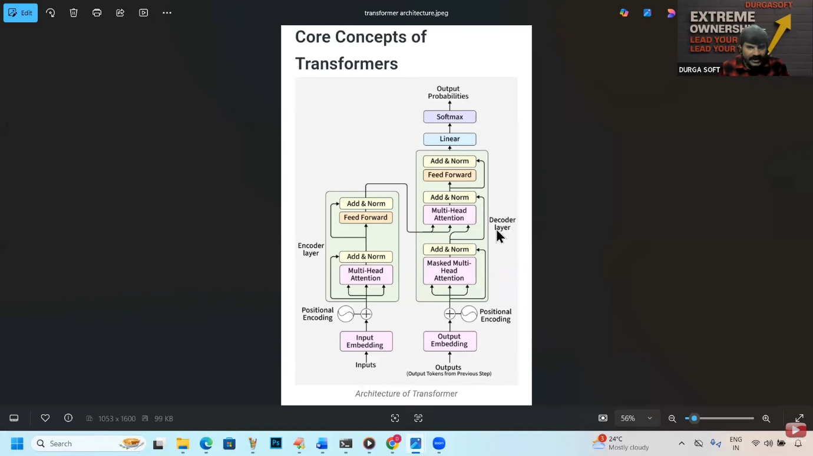

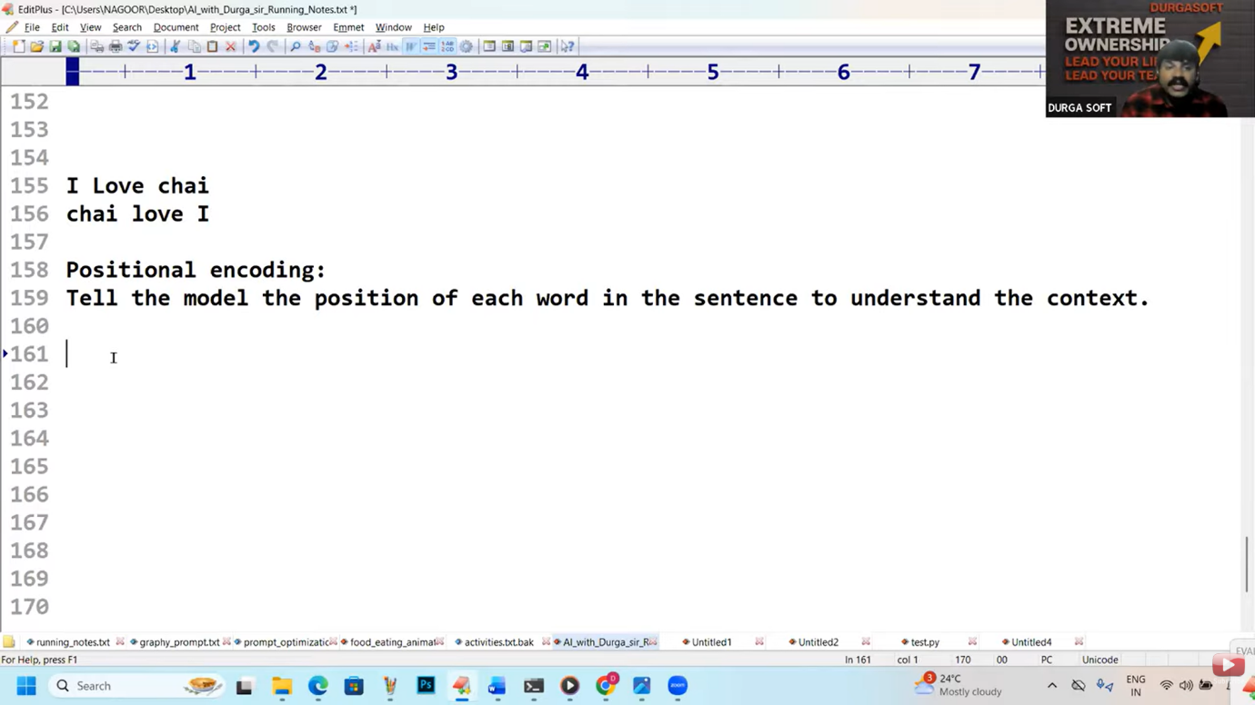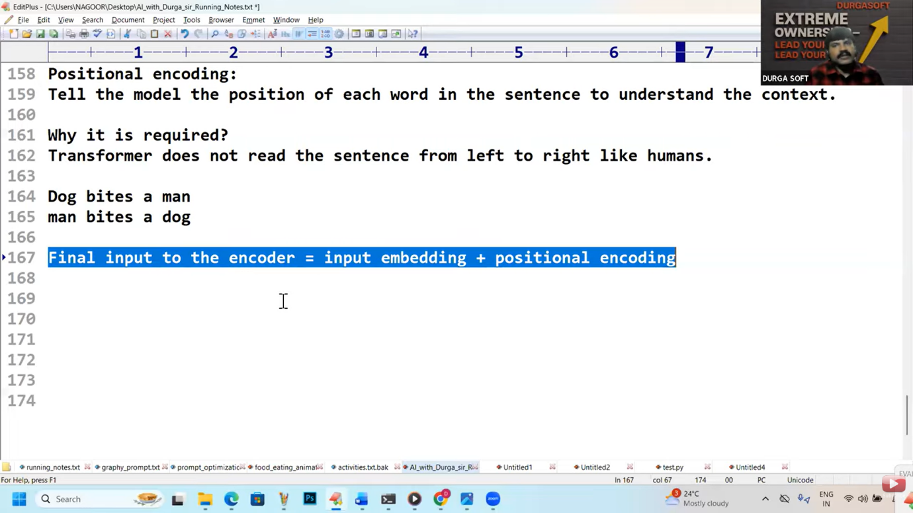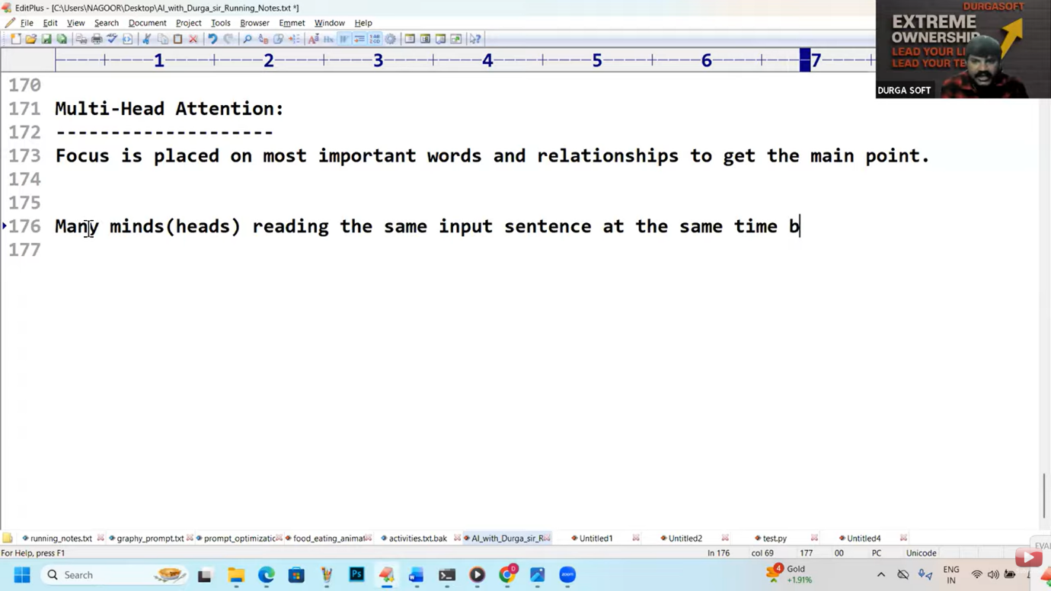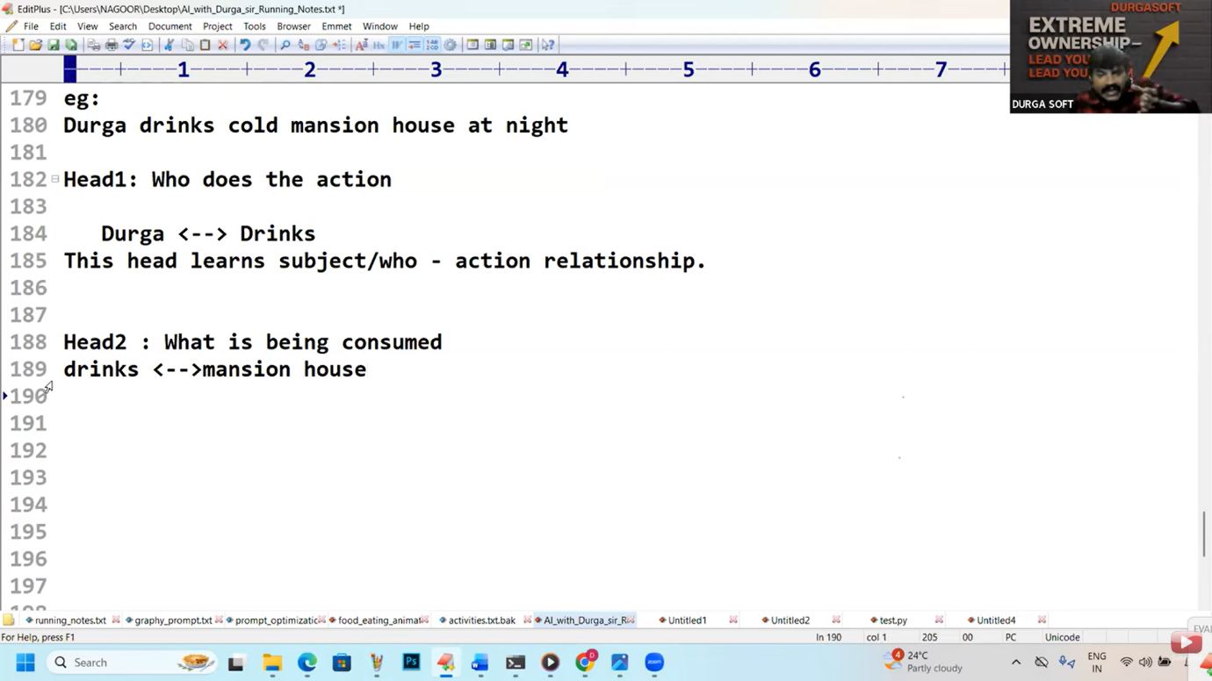

**Theorey  
  
https://youtu.be/X8j_4j50lII     CPU VS GPU Vs TPU**

**https://youtu.be/7aS6f_Px3io     Attention**

**How to implement custom tokenizer:**

**----------------------------------**

**tiktoken - library can be used to convert from user input to gpt understandable numeric tokens(encoding) and to convert gpt understandable numeric token to human understandable word(decoding)**

**pip install tiktoken**

**Dog bites a man**

**man bites a dog**

**I Love chai**

**chai love I**

**Positional encoding:**

**Tell the model the position of each word in the sentence to understand the context.**

**Why it is required?**

**Transformer does not read the sentence from left to right like humans.**

**Dog bites a man**

**man bites a dog**

**Final input to the encoder = input embedding + positional encoding**

**Multi-Head Attention:**

**--------------------**

**Focus is placed on most important words and relationships to get the main point.**

**Many minds(heads) reading the same input sentence at the same time, but each**

**mind looks for a different meaning.**

**eg:**

**Durga drinks cold mansion house at night**

**Head1: Who does the action**

**Durga <--> Drinks**

**This head learns subject/who - action relationship.**

**Head2 : What is being consumed**

**drinks <-->mansion house**

**This head learns action-object relationship**

**Head3 : Property / Quality**

**Cold <--->Mansion house**

**Learns attribute relation**

**Head4: Time**

**night -->drinks**

**Learns when this action happens**

**Head5 = type/category**

**mansion house -->drink type**

**This is liquid not a food**

**All these heads work in parallel to find the meaning and relationships.**

**Add and Norm:**

**------------**

**Add: We have to add attention output with original input**

**Add = original input+attention output.**

**Normalization:**

**keep values small and balanced**

**It prevents overflow and confusion.**

**Feed Forward:**

**------------**

**Each input word is individually refined.**

**Meaning is strengthend.**

**Durga ---> understand as a person**

**Drinks --->understand as action**

**cold ---> understand as quality/condition**

**mansion house -->understand as a drink item**

**at night --> understand as time information**

**Note:**

**Attention = Connecting words**

**Feed Forward = Polishing each word**

**1. Decoder Input:**

**----------------**

**Decoder does not start from zero**

**It takes already generated words.**

**First time it starts with a START Token.**

**2. Ouput embedding:**

**-------------------**

**Words are converted into numbers as transformer can understand only numbers.**

**3. Positional encoding:**

**------------------------**

**Position of word is added.**

**Without position meaning will be changed.**

**dog bites a man**

**man bites a dog**

**4. Masked multi head self attention:**

**------------------------------------**

**Decoder looks only at past words.**

**Future words are hidden(masked)**

**This masking concept is applicable at the time of training where total output statement is visible.**

**Maksing is not required at the time of using the model.**

**Masked attention hides future words so that model learns to predict, not copy.**

**Prevents cheating.**

**Add and Norm(After Masked Multi head attention):**

**-----------------------------------------------**

**Original input added back.**

**values are normalized.**

**Keep learning stable.**

**Avoids confusion.**

**Multi head attention(Encoder-Decoder attention):**

**----------------------------------------------**

**Decoder looks at encoder output.**

**Connects input meaning with output generation.**

**Helps generate correct and relavant words.**

**Feed forward network:**

**--------------------**

**Extra thinking layer.**

**improves understanding quality.**

**helps grammer and structure.**

**Linear:**

**-------**

**It is the last thinking step.**

**It converts model thinking into word scores.**

**It does not choose the word.**

**It only prepare options.**

**Softmax layer:**

**-------------**

**converts scores into probabilities.**

**Choose the best next word.**

**Highest probability word will be selected.**

**For each word, decoder does:**

**1. Look at past words (Masked Multi head attention)**

**2. Look at input meaning (cross attention | encoder-decoder multihead attention)**

**3. Think deeper (Feed forward)**

**4. Score all words(Linear Layer)**

**5. Pick one word( Softmax Layer)**

**Encoder input understanding: What is todays weather?**

**Decoder output : Rain is heavy**

**Step-0: START token**

**Tells the decoder**

**'start generating output'**

**You open the mouth to speak.**

**No word spoken yet.**

**Decoder has [START]**

**step-1:**

**------**

**Masked multi head attention look only past words.**

**No words generated yet**

**Decoder sees only [START]**

**Step-2: Cross attention[Look at encoder meaning]**

**you remeber the question**

**Describe todays weather?**

**Decoder thinks:**

**I must talk about weather.**

**Step-3: Feed Forward Network[Extra thinking]**

**Decoder thinks:**

**weather --- rain.. may be start with rain**

**Step4: Linear layer scores to all words**

**Rain**

**Sun**

**Wind**

**Softmax picks the best word: rain**

**Step-5: Masked Multi head attention(Second round)**

**Alreay said: Rain**

**Decoder thinks: Sentence is not complete**

**Decoder sees: Rain**

**Step-6: Cross attention:**

**Re checks input meaning**

**Avoids going off topic**

**Questions remainder: Describes todays weather?**

**Decoder thinks: I should describe rain**

**Step7: Feed forward:**

**Extra thinking layer.**

**Describes grammer pattern and structure?**

**Rain .... is ... something**

**step8: Linear + softmax:**

**-----------------------**

**Options:**

**is**

**was**

**falls**

**softmax selected is**

**Second word generated: is**

**Step9: Masked multi head attention(3rd round)**

**Keep track of sentence so far**

**Decoder sees: Rain is**

**Listener expects more**

**Step-10: Cross attention + Feed forward**

**Decide description word**

**Keep answer aligned to input**

**Decoder think: How is rain?**

**Step11: Liner + softmax**

**options:**

**heavy**

**sweet**

**fast**

**Third word generated: Heavy**

**Rain is heavy.**

**Video 14 Quizz  
  
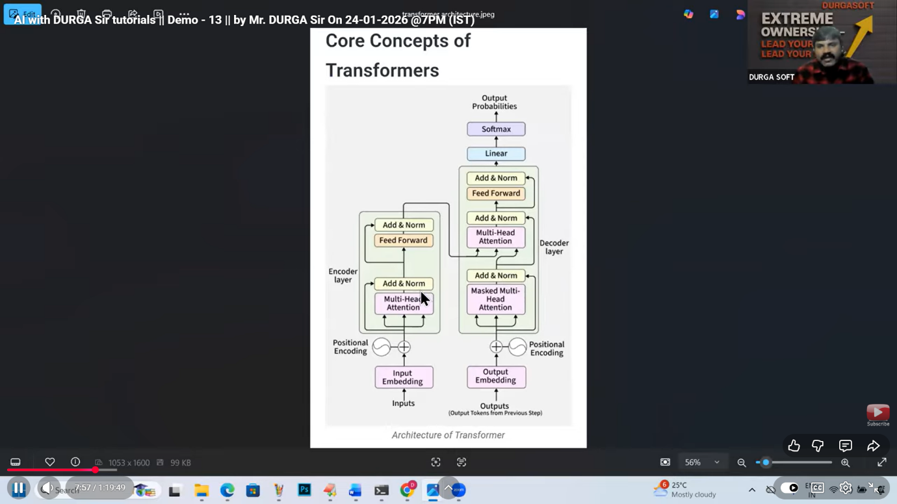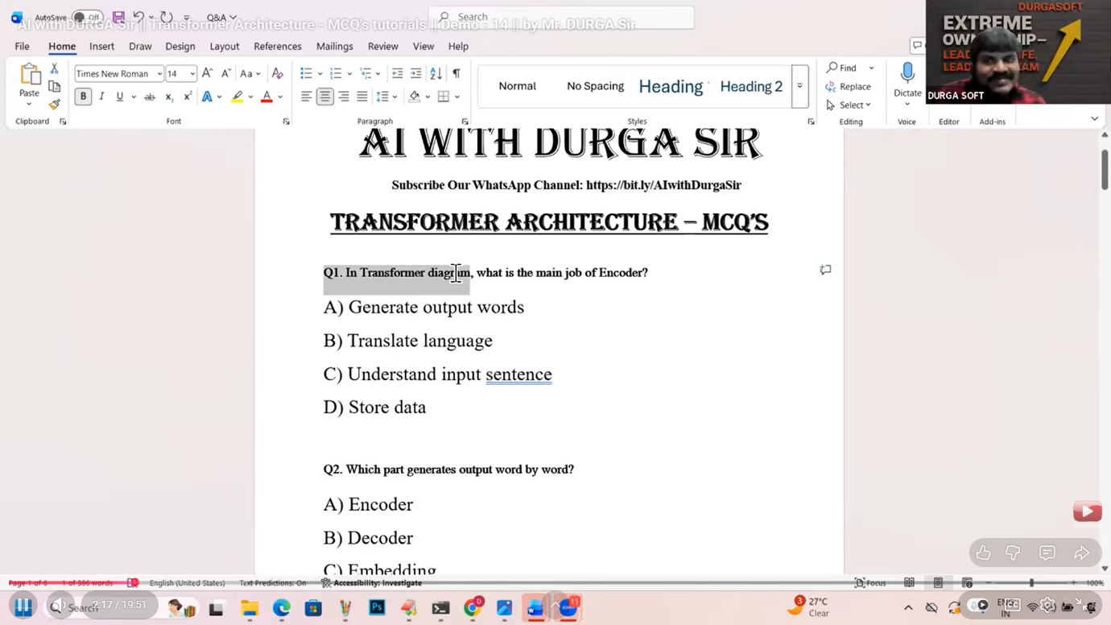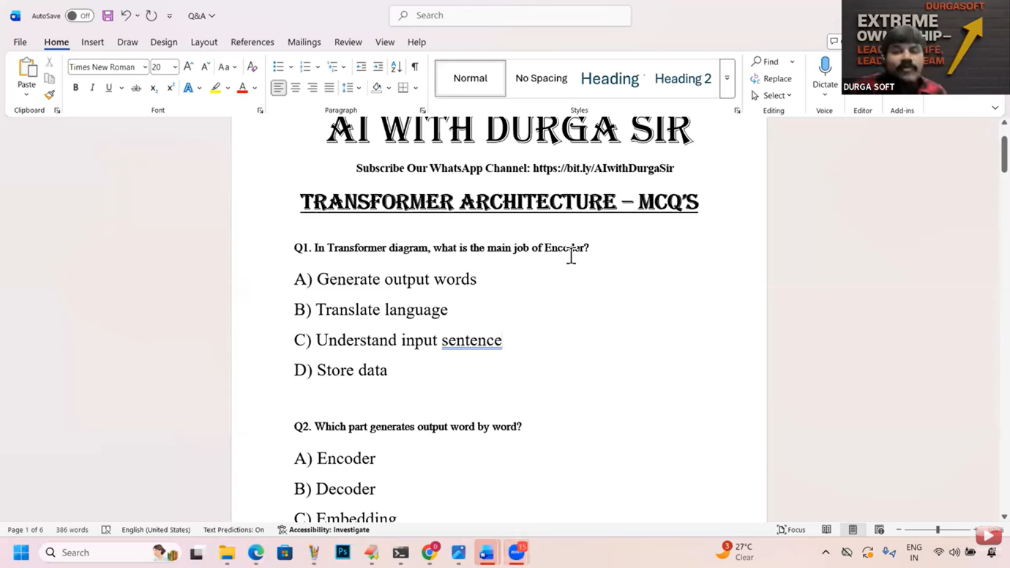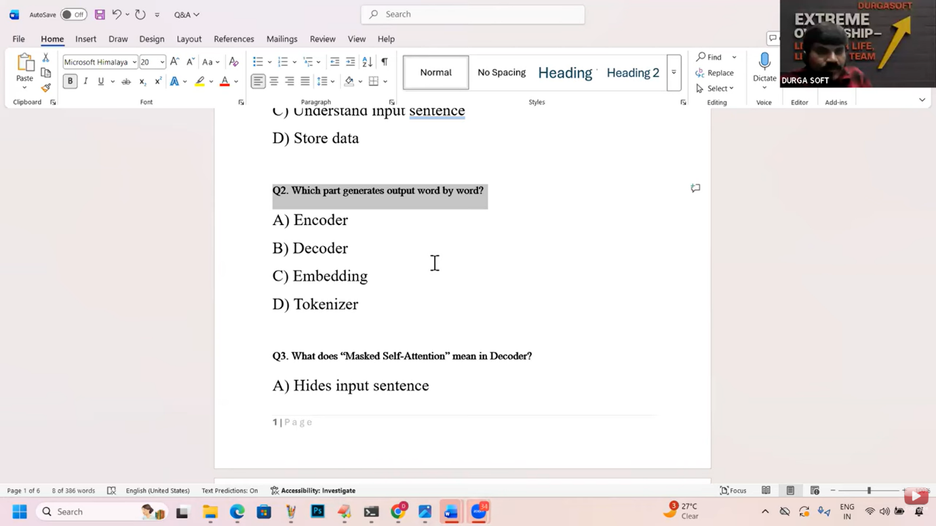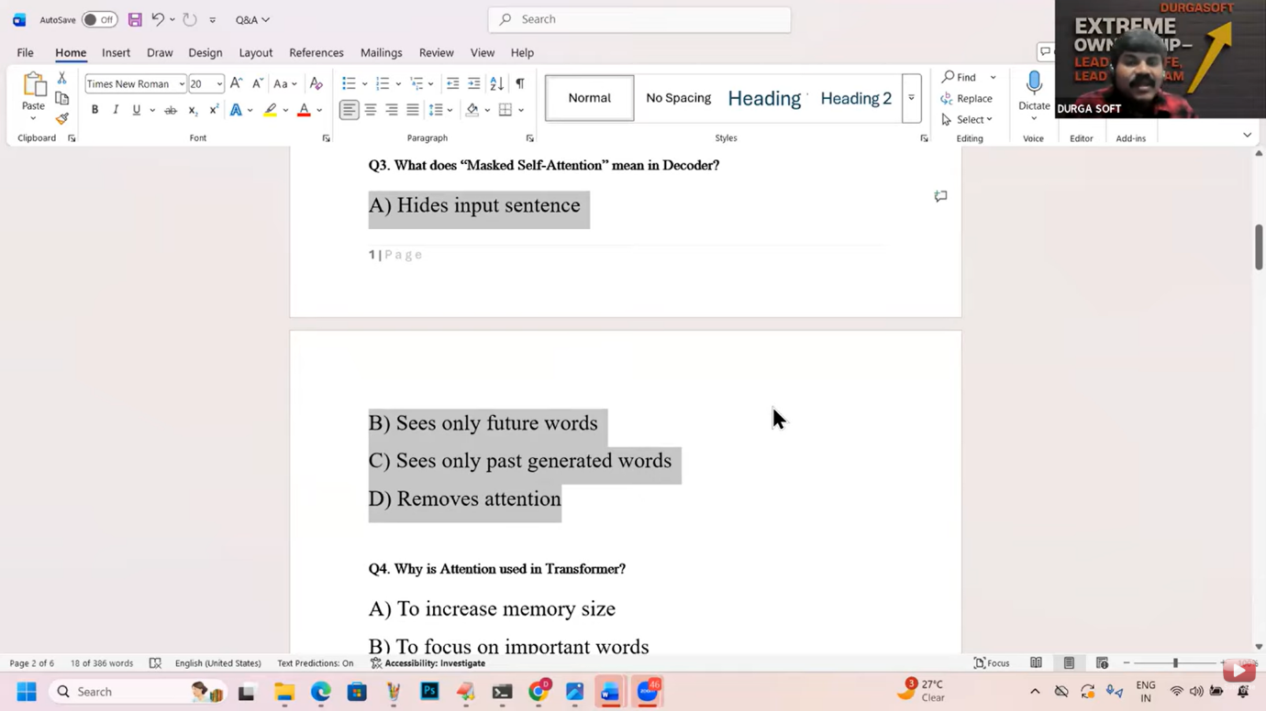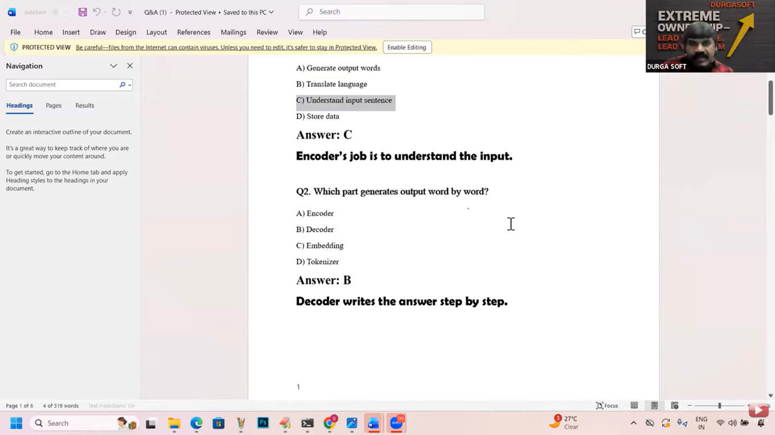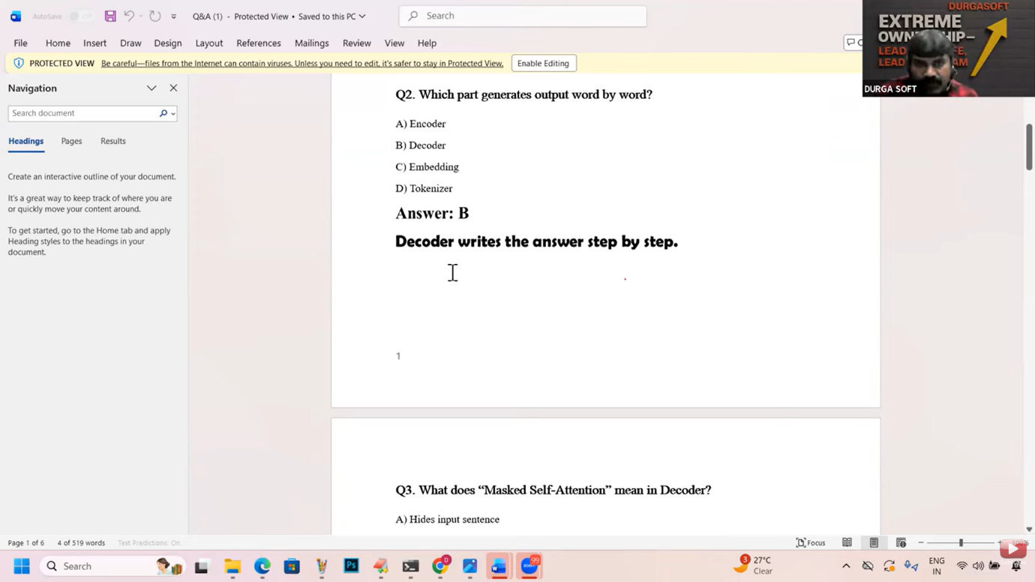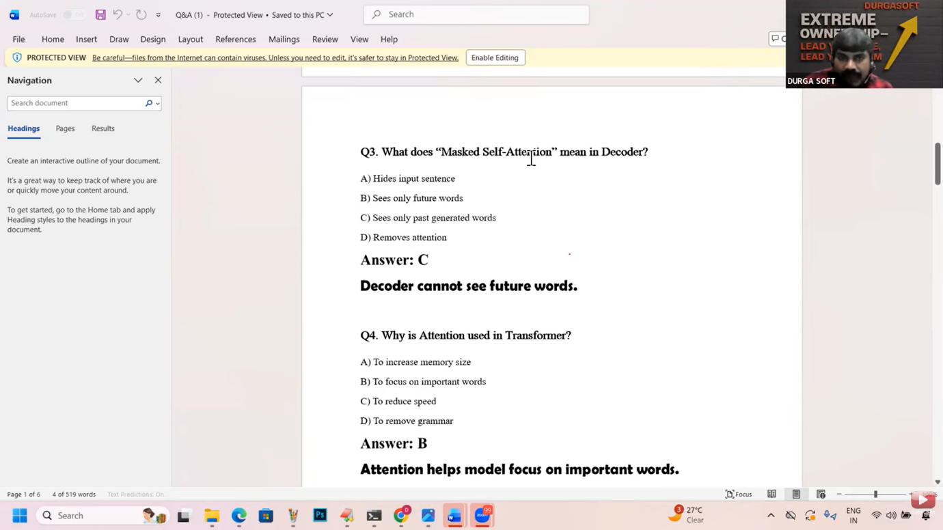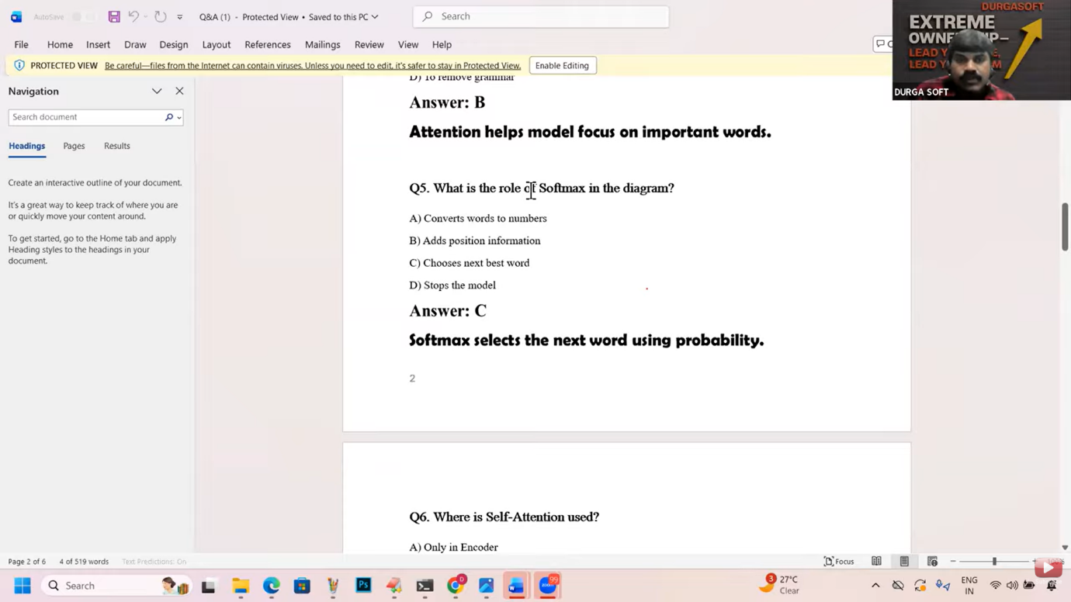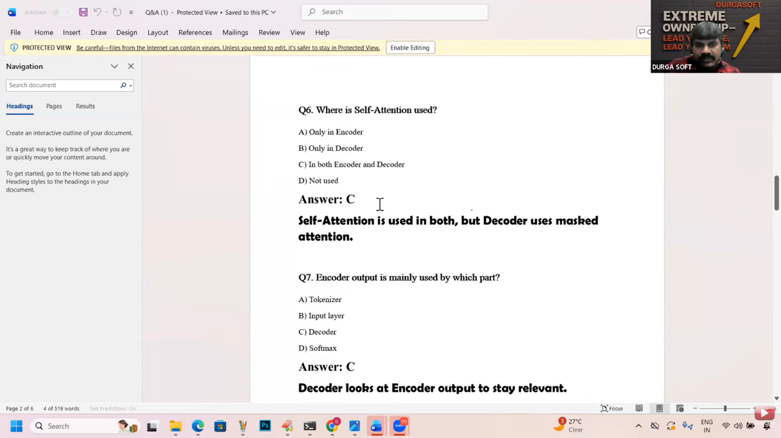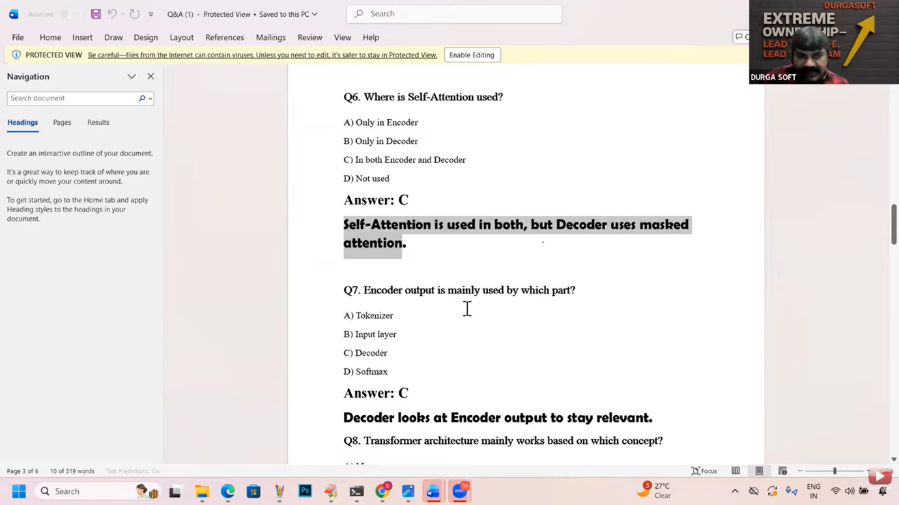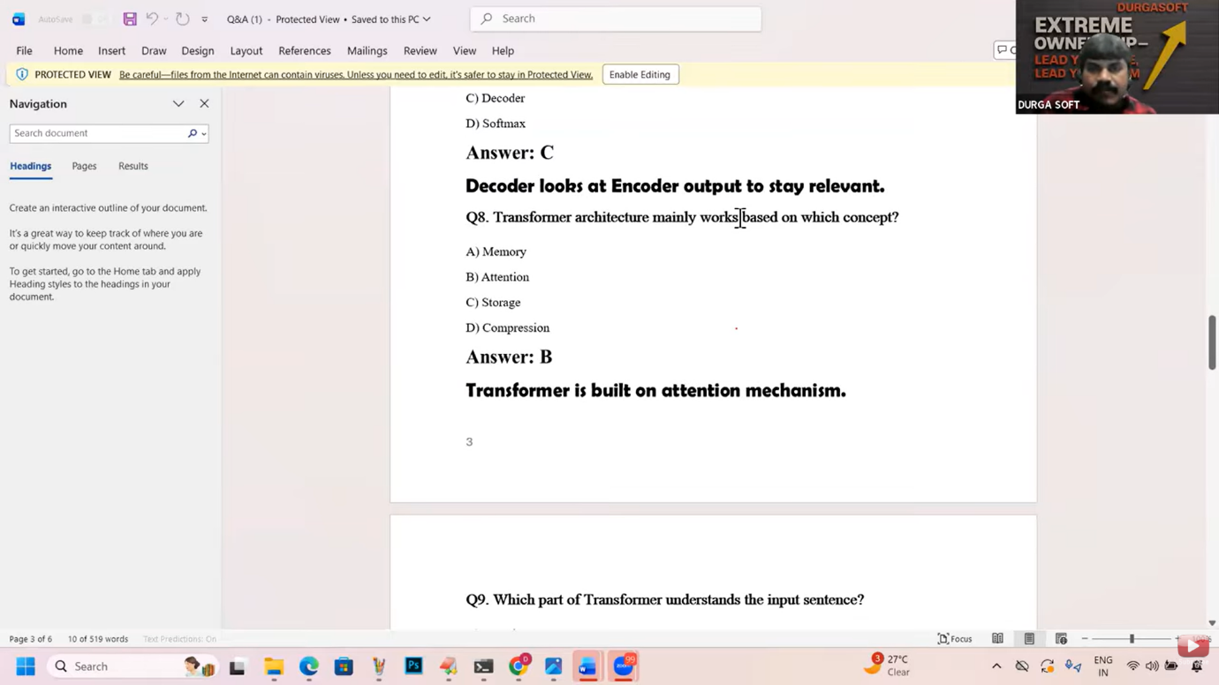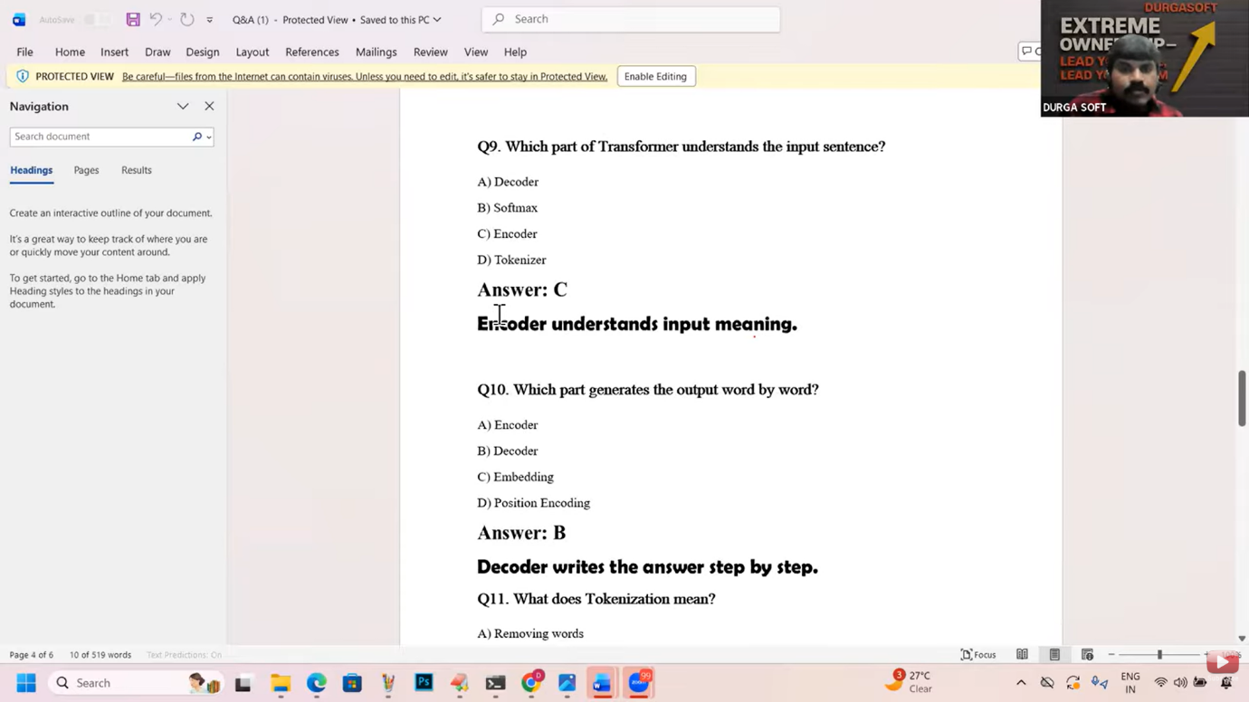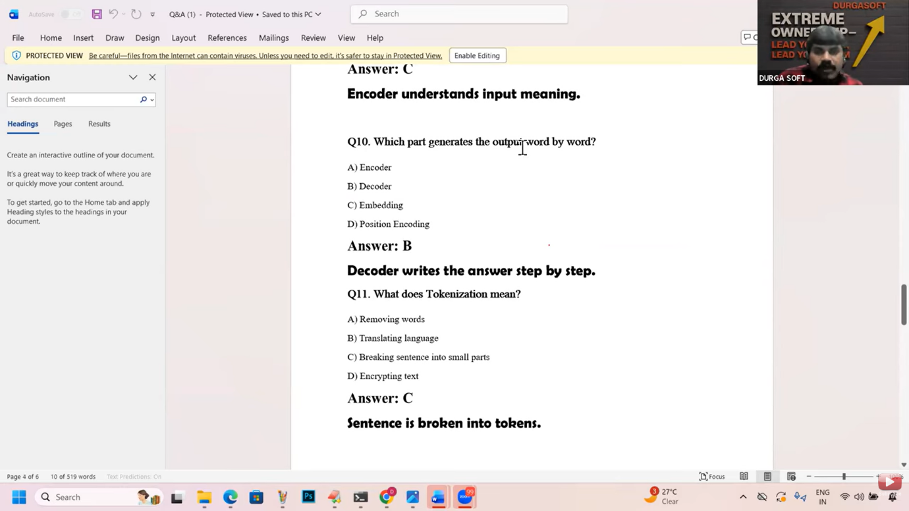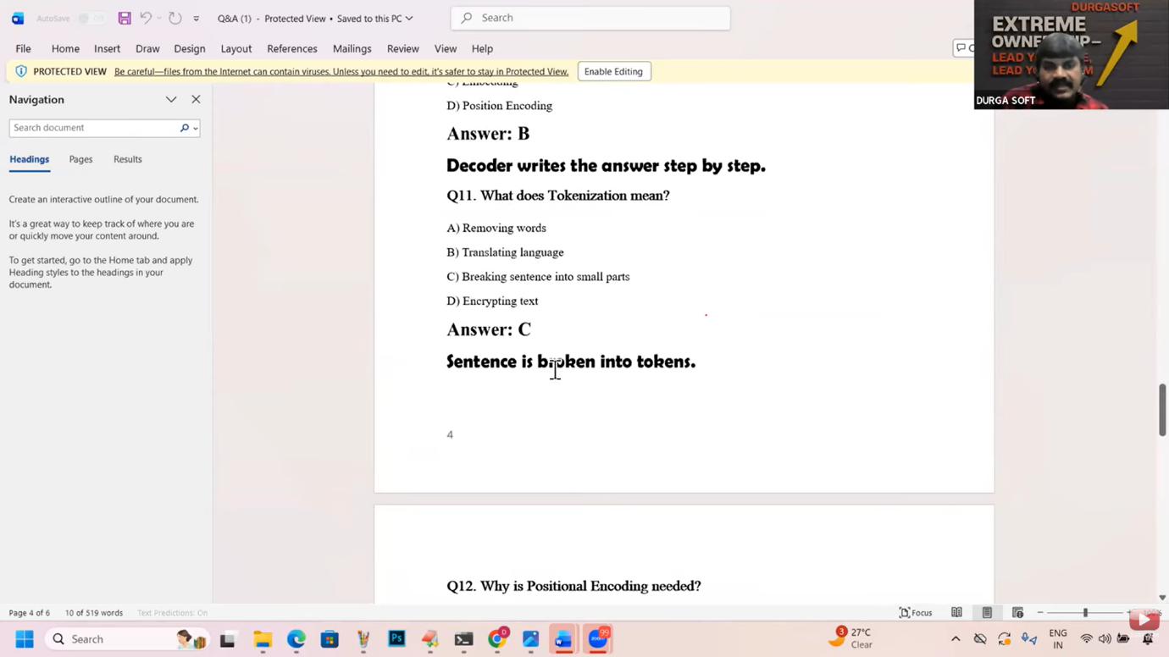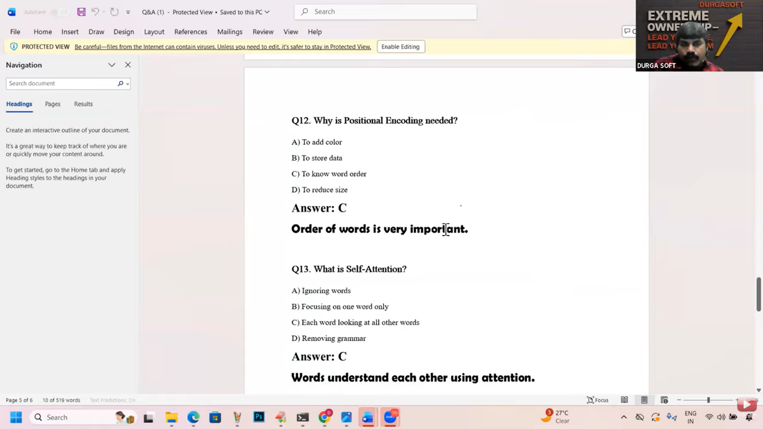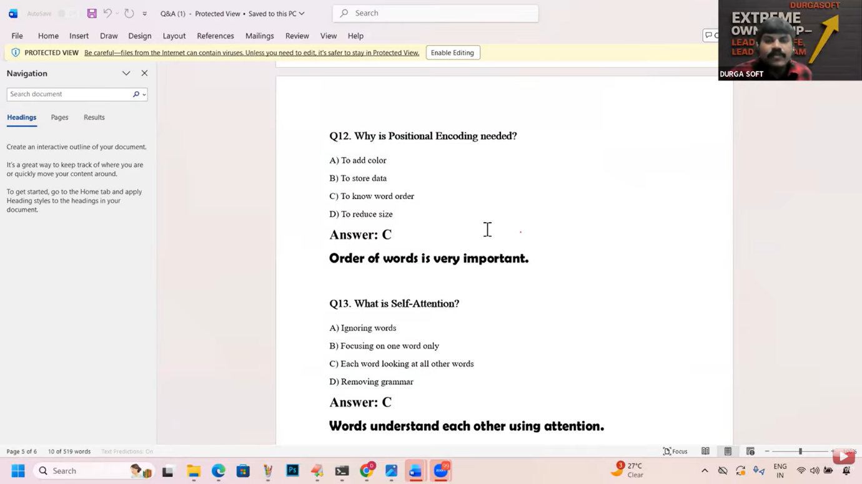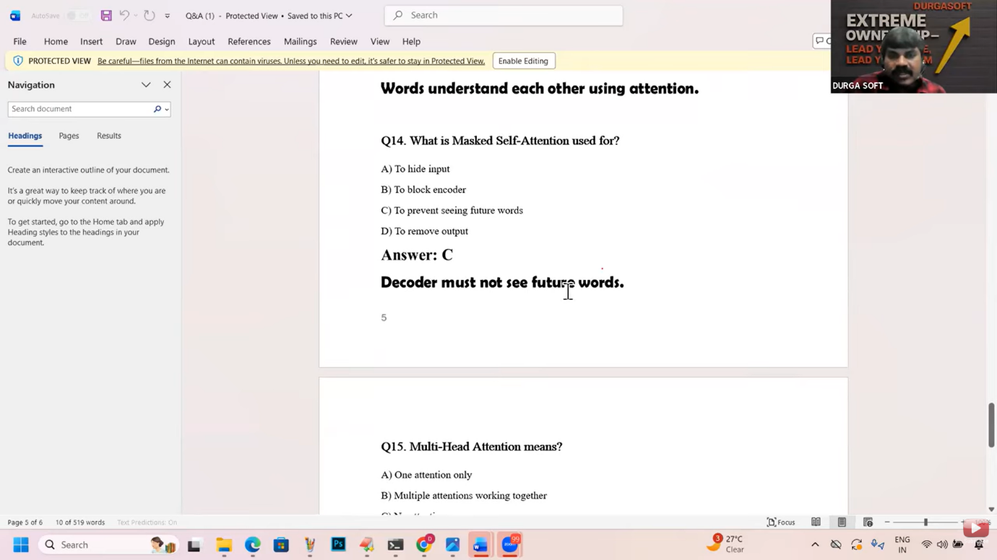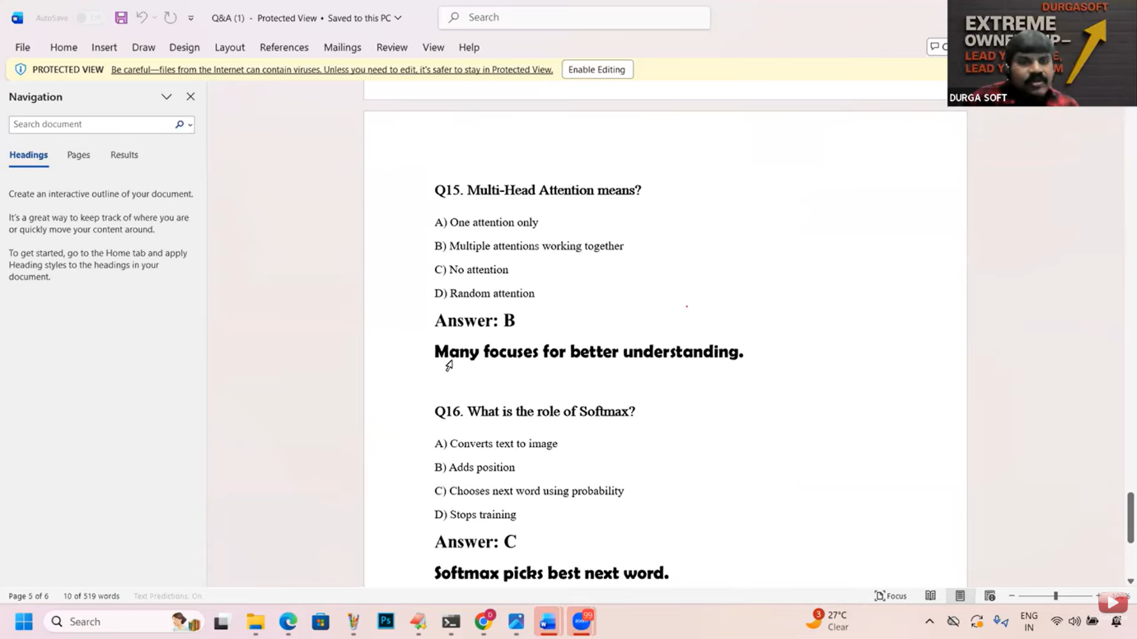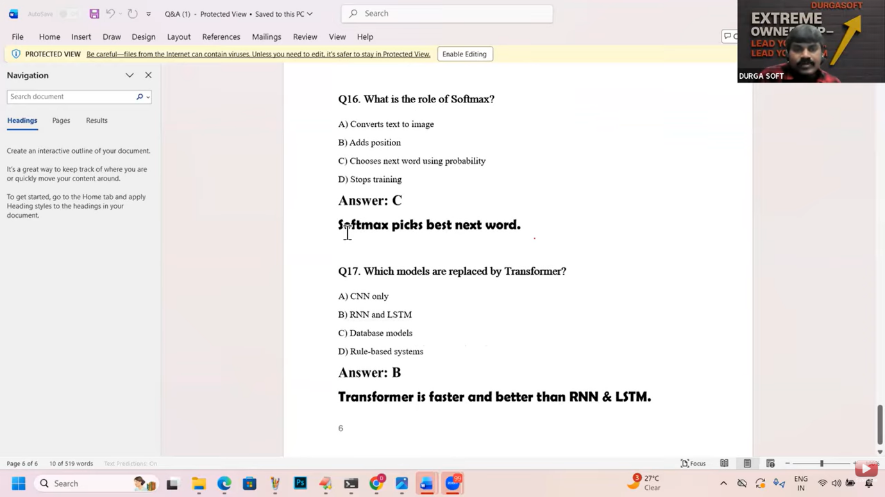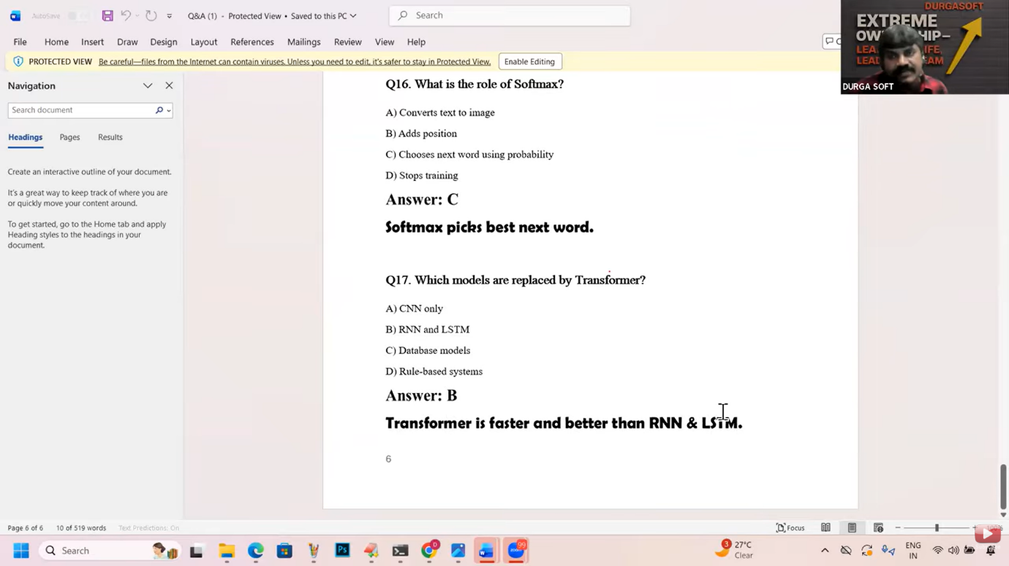**

**Video 16 :- Linear Regression   
Training a small Model to predict salary and Marks.  
Using Linear Regression and sklearn from python.  
  
if the input depednds on output then we choose Linear regression.  
  
Input data:**

**-----------**

**1 hour ---> 35 marks**

**2 hours ---> 40 marks**

**3 hours ---> 50 marks**

**4 hours ---> 60 marks**

**5 hours ---> 75 marks**

**sklearn-->very popular python library for ML**

**Model**

**Train this model with my input data**

**predict my required output**

**model.fit(hours,marks)**

**Model looks at hours and marks**

**Model finds relationship**

**It will create some equation like:**

**marks = m*hours + b**

**m = slope(how fast marks increase)**

**b = base marks(standard value)**

**from sklearn.linear_model import LinearRegression**

**model = LinearRegression() # we are creating an empty brain**

**hours = [[1],[2],[3],[4],[5]]**

**marks = [35,40,50,60,75]**

**model.fit(hours,marks) # learning from data**

**print(model.predict([[6]])) #predicting the output [82]**

**print(model.predict([[7]])) #predicting the output [92]**

**Predict salary based on exp:**

**from sklearn.linear_model import LinearRegression**

**model = LinearRegression() # we are creating an empty brain**

**experience = [[0],[1],[2],[3],[4],[5]]**

**salary = [10,15,22,30,38,50]**

**model.fit(experience,salary) # learning from data**

**print("The predicted salary for 10 years of exp:",model.predict([[10]]))**

**print("The predicted salary for 20 years of exp:",model.predict([[20]]))**

**--------**

**import random**

**words = ['morning','evening','night']**

**probability = [0.6,0.3,0.1]**

**print("Usually I am taking tea at:", random.choices(words,probability))**

**Video 17  
Context Window  
Personal Context  
Hallucinations.  
  
Video 17**

**How GPT remember things:**

**------------------------**

**GPTs work with 2 types of memory.**

**1. Context Window(Working Memory- Temporary)**

**2. Personal context (Long-term Archive)**

**1. Context Window(Working Memory- Temporary)**

**It remembers what we talk inside one chat.**

**When the chat ends it is cleared.**

**Capacity is limited. If this chat becomes 500 pages long, it will start**

**forgetting the very first messages.**

**2. Personal context (Long-term Archive)**

**This is long term memory.**

**It remembers important user details like**

**name, learning style, preperences**

**It works across many chats.**

**Context window = remembers the current chat conversation**

**Personal context = remembers the person across multiple chats**

**Hallucination in AI:**

**--------------------**

**AI gives an answer that looks correct, sounds confident, but is actually**

**wrong or not verified. This is called Hallucination.**

**Reasons for Hallucination:**

**1. GPT predicts, not checks**

**2. Missing or confusing data**

**model may not have:**

**exact latest information**

**Exact local information**

**3. Your prompt is vague**

**How to reduce Hallucination:**

**----------------------------**

**1. Ask for sources**

**say: Give sources or links**

**2. Ask it to say I dont know**

**Say: If you are not sure, say you are not sure.**

**3. Be specific**

**vague: Tell about java**

**specific: Explain java 21 virtual threads in simple words with one example.**

**Strengths and Limitations of GPTs:**

**----------------------------------**

**Strengths:**

**1. Explaining concepts clearly**

**explaining basics**

**breaking complex topics**

**give examples**

**2. Writing and Drafting content**

**GPT can:**

**write emails**

**create resumes**

**draft documents**

**prepare notes**

**3. Coding Help**

**GPT can:**

**explain code**

**generate sample code**

**debug simple issues**

**4. Language and communication**

**grammer correction**

**setence rewriting**

**translation**

**summarization**

**5. Brainstormiong and Ideas**

**GPT is good for:**

**project ideas**

**startup ideas**

**learning paths**

**topic suggestions**

**GPT Limitations:**

**1. No real understanding or emotions**

**GPT cannot**

**think**

**feel**

**understand like humans**

**It just predict words thats all**

**2. Can be confidently wrong**

**Hallucination**

**Never trust blindly for facts**

**3. No real time awareness**

**GPT may not:**

**know latest news**

**know live prices**

**know today's events**

**unless connected to tools**

**4. No responsibility**

**If GPT gives wrong advice:**

**GPT is not responsible**

**you are responsible**

**So never use GPT for:**

**medical decisions**

**legal decisions**

**financial investment decisions**

**without expert verification**

**if task is learning or drafting:**

**use GPT confidently**

**elif task is critical decision:**

**verify with experts**

**else:**

**use GPT as assistant, not authority**